**Screenshot of three self-designed queries**

**We have put the retrieval and Generation steps together to get answers for any of the questions**

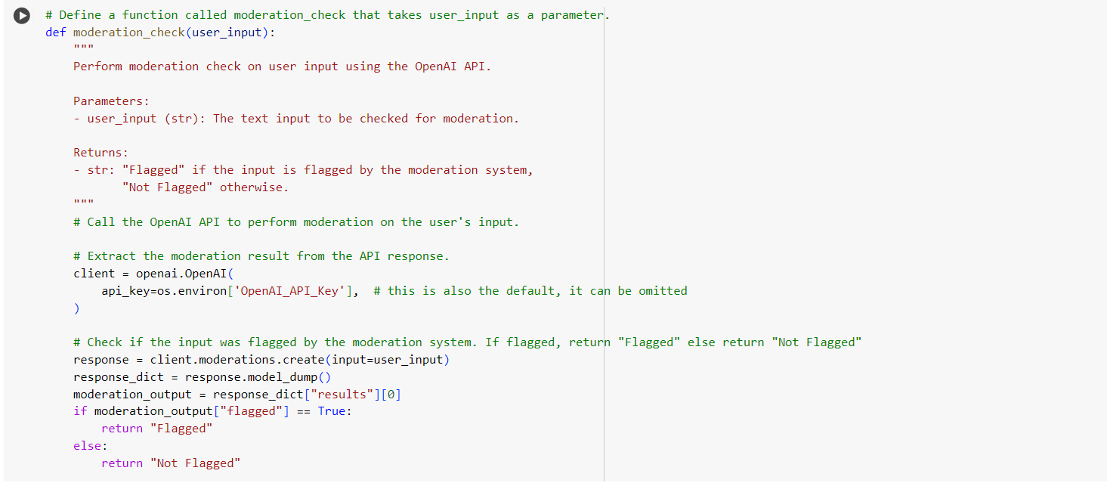

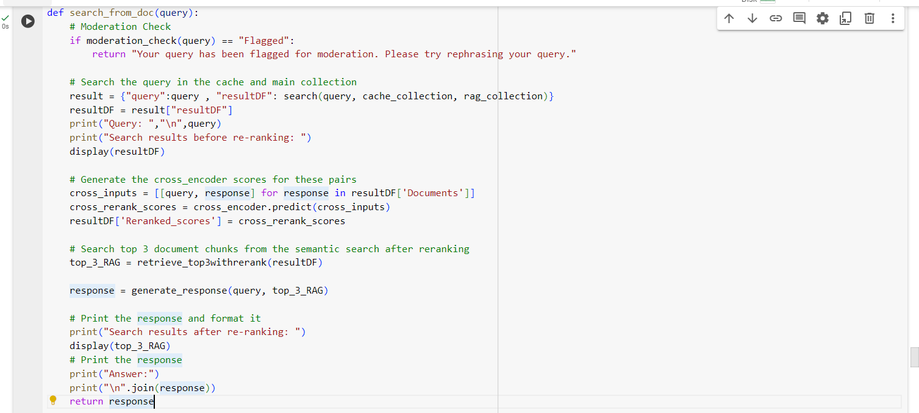

**Prompt 1: Focused Fact Finding**

* **Query:** "What are the key benefits provided under this life insurance policy?
* **Intent:** Tests the system's ability to:
  + Locate specific factual information within insurance documents.
  + Provide a concise answer with appropriate citations.

**Input Screenshot**

**Top 3 results from semantic search**

**Generation Layer:**

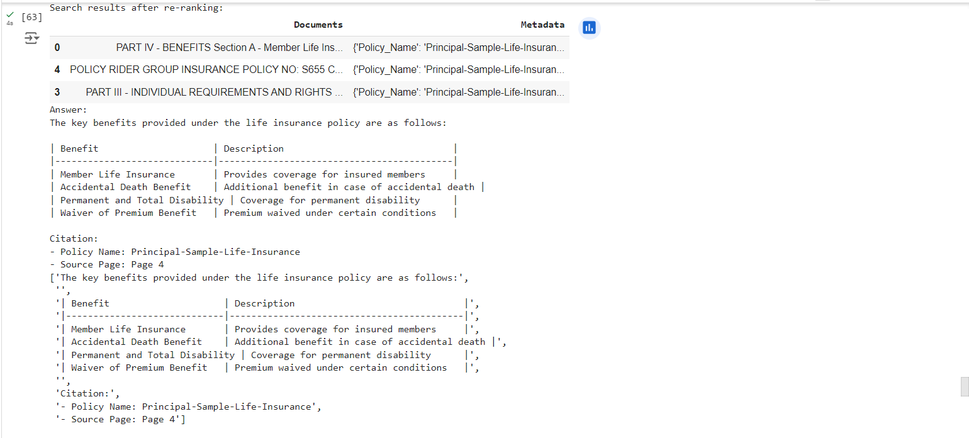

**Top 3 results from Generation Layer**

**Final Output**

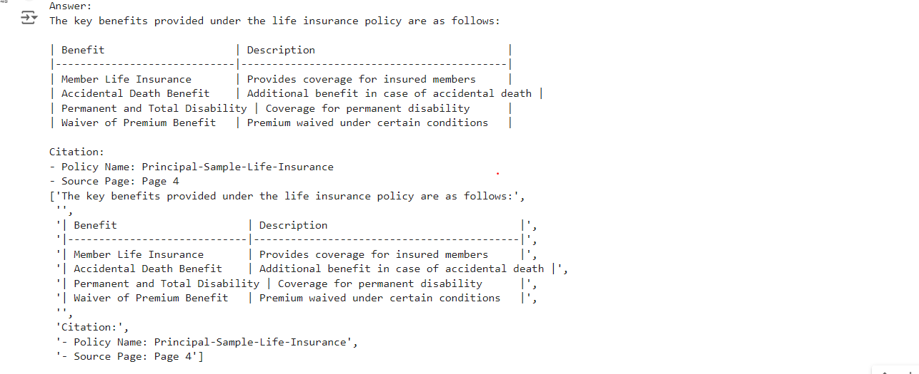

**Prompt 2: Understanding Coverage**

* **Query:** Can partial withdrawals be made from the policy’s cash value? If so, what are the conditions?
* **Intent:** Assesses if the system can:
  + Understand a more nuanced question about policy coverage.
  + Search potentially multiple sections of the documents for relevant information.
  + Present the answer in a clear and well-structured way, addressing both the main question and any limitations.

**Input Screenshot**

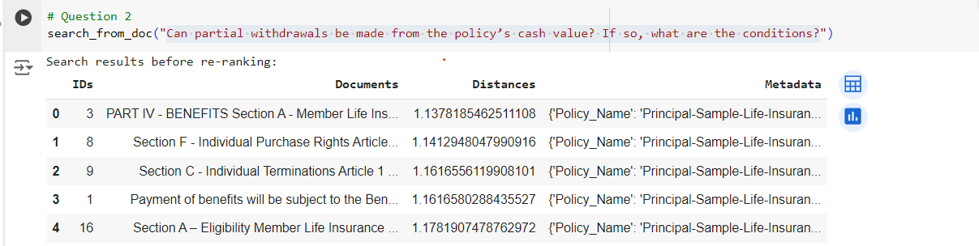

**Top 3 results from Semantic search**

**Top 3 results from Generation layer**

**Final Output**

**Prompt 3: Surrender and Termination Query**

* **Query:** Under what circumstances can the insurance company terminate the policy?
* **Intent:** Tests how Mr. HelpMate AI handles subjective or open-ended queries.
  + Ideally, the system should recognize the lack of objective answerability.
  + A good response would explain that it cannot determine if a plan is "good" without more context about the user's needs, but might offer to help find information about specific factors to consider.

**Input Screenshot**

**Top 3 results from semantic search**

**Top 3 results from generation layer**

**Final Output**

